**Custom Email Draft Generator**

**Aim :**

The purpose of this project is to develop a custom email draft generator using OpenAI's GPT models to,

1. Facilitate users in writing professional email drafts without hassle.
2. Enable users to personalize their emails by selecting:
3. The role or relationship of the recipient.
4. The purpose of the email.
5. The tone, whether formal, casual, friendly, etc.
6. Save time in drafting emails and maintain clarity and coherence in the communication.

The use of Streamlit creates a very interactive and user-friendly web application where users input parameters to generate customized drafts of emails in real-time.

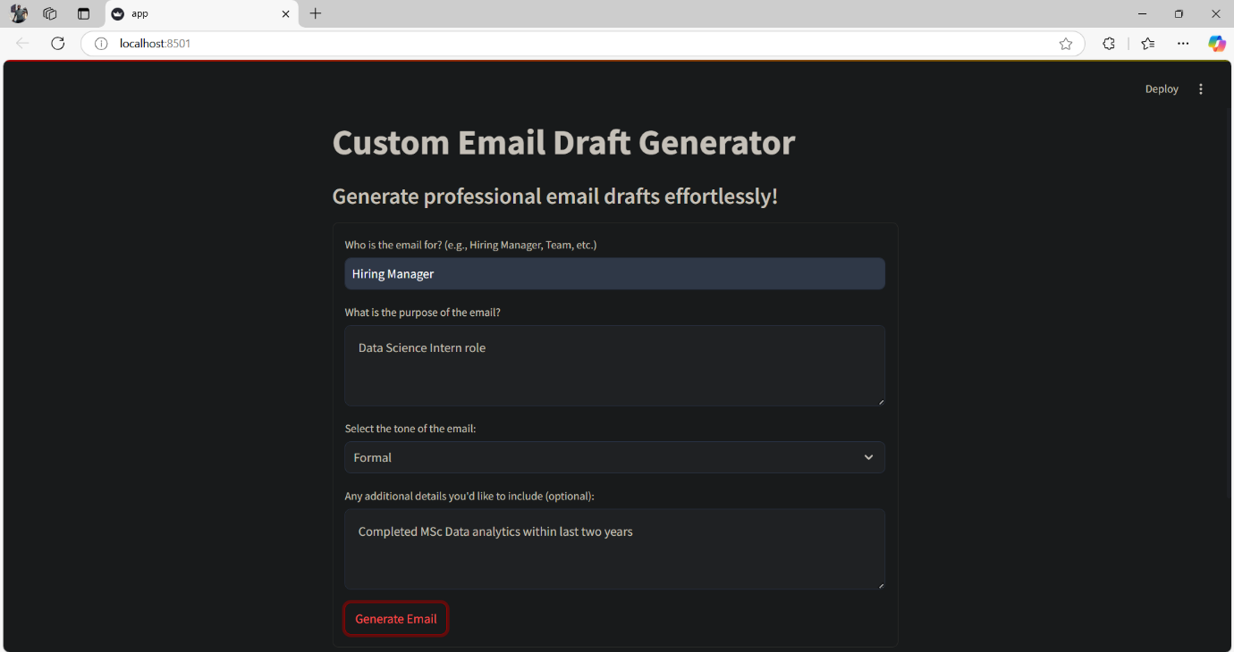

**Result of the Project:**

The outcome of the project is a working web application that:  
  
1. Produces Professional Emails:

Users input the recipient, purpose, and tone.  
 The app automatically produces a clear and polished draft of the email in real-time.

2. Custom Outputs:

The app adjusts the output according to the tone and purpose defined by the users so that the outputted email matches their intended requirements.  
  
3. User-Friendly Interface:

Developed with Streamlit, the application provides a simple and user-friendly interface that does not require technical knowledge to use.  
  
  
4. Scalable and Versatile:

The app can be applied to different contexts, such as job applications, team communication, or client outreach.